Programming with Python- I

HANGMAN Game Development

* Hangman is a guessing game for two or more players.
* One player thinks of a word, phrase or sentence and the other(s) tries to guess it by suggesting letters within a certain number of guesses.
* The word to guess is represented by a row of dashes representing each letter of the word.
* Rules may permit or forbid proper nouns, such as names, places, brands, or slang. If the guessing player suggests a letter which occurs in the word, the other player writes it in all its correct positions.
* If the suggested letter does not occur in the word, the other player removes (or alternatively, adds) one element of a hanged stick figure as a tally mark.
* Generally, the game ends once the word is guessed, or if the stick figure is complete — signifying that all guesses have been used.

MODULES used in the code:-

Random:

Python Random module is an in-built module of Python which is used to generate random numbers. These are pseudo-random numbers means these are not truly random. This module can be used to perform random actions such as generating random numbers, print random a value for a list or string, etc.

Time:

Time module in Python is used for various time related functions in the python program. We can print time,control the time required to print the statements using time.sleep() function.

**Source Code:**

import random

import time

# Initial Steps to invite in the game:

print("\nWelcome to Hangman game by RUIA COLLEGE FY Students\n")

time.sleep(1.5)

name = input("Enter your name: ")

print("Hello " + name + "! Best of Luck!")

time.sleep(1.5)

print("The game is about to start!")

time.sleep(1.5)

*#loop to select level*

def level():

global randomWord

global wordDictionary

global answer

global wordDictionary1

global wordDictionary2

answer = input('Which level of the game would you like to play(easy/medium/hard) ?').lower()

if(answer=='easy'):

randomWord = random.choice(wordDictionary)

elif(answer=='medium'):

randomWord = random.choice(wordDictionary1)

elif(answer=='hard'):

randomWord = random.choice(wordDictionary2)

else:

print("Wrong Choice")

level()

*# The basic parameters we need to run the game:*

def main():

global count

global display

global randomWord

global already_guessed

global length

global play_game

global answer

global wordDictionary

global wordDictionary1

global wordDictionary2

wordDictionary = ["college", "object", "rose", "delhi","virat","hello", "python", "station", "gui",'lotus']

wordDictionary1 = ['daffodils','tuple','directory','modules','oxford','lavender','orchid','varanasi','sydney','rossum']

wordDictionary2 = ['thiruvananthapuram','github','linkedin','snapseed','massachusetts','periwinkle','chrysanthemum','mongodb','bakerstreet','vecna']

*### Choosing a random word from wordDictionary*

level()

time.sleep(1)

print("Let's play Hangman!")

length=len(randomWord)

count = 0

display = '_' * length

already_guessed = []

play_game = ""

*# A loop to re-execute the game after the first round ends*:

def play_again():

global play_game

ans = input("Would you like to play again? (Yes/No)\n").lower()

if (ans == "yes"):

main()

elif (ans == "no"):

print("Thanks For Playing! We expect you back again!")

exit()

else:

print("Wrong Choice")

play_again()

*# Initializing all the conditions required for the game to run smoothly:*

def hangman():

global count

global display

global randomWord

global already_guessed

global play_game

limit = 7

guess = input("This is the Hangman Word: " + display + " Enter your guess: \n")

guess = guess.strip()

if len(guess.strip()) == 0 or len(guess.strip()) >= 2 or guess <= "9":

print("Invalid Input, Try a letter\n")

hangman()

elif guess in randomWord:

already_guessed.extend([guess])

index = randomWord.find(guess)

randomWord = randomWord[:index] + "_" + randomWord[index + 1:]

display = display[:index] + guess + display[index + 1:]

print(display + "\n")

elif guess in already_guessed:

print("Try another letter.\n")

else:

count += 1

if count == 1:

print(" _____ \n"

" | | \n"

" | \n"

" | \n"

" | \n"

" | \n"

" | \n"

"__|__\n")

print("Wrong guess. " + str(limit - count) + " guesses remaining\n")

elif count == 2:

print(" _____ \n"

" | | \n"

" | O\n"

" | \n"

" | \n"

" | \n"

" | \n"

"__|__\n")

print("Wrong guess. " + str(limit - count) + " guesses remaining\n")

elif count == 3:

print(" _____ \n"

" | | \n"

" | O\n"

" | | \n"

" | \n"

" | \n"

" | \n"

"__|__\n")

print("Wrong guess. " + str(limit - count) + " last guess remaining\n")

elif count == 4:

print(" _____ \n"

" | | \n"

" | O\n"

" | |\ \n"

" | \n"

" | \n"

" | \n"

"__|__\n")

print("Wrong guess. " + str(limit - count) + " last guess remaining\n")

elif count == 5:

print(" _____ \n"

" | | \n"

" | O\n"

" | /|\ \n"

" | \n"

" | \n"

" | \n"

"__|__\n")

print("Wrong guess. " + str(limit - count) + " last guess remaining\n")

elif count == 6:

print(" _____ \n"

" | | \n"

" | O\n"

" | /|\ \n"

" | \ \n"

" | \n"

" | \n"

"__|__\n")

print("Wrong guess. " + str(limit - count) + " last guess remaining\n")

elif count == 7:

print(" _____ \n"

" | | \n"

" | O\n"

" | /|\ \n"

" | / \ \n"

" | \n"

" | \n"

"__|__\n")

print("Wrong guess. You are hanged!!!\n")

print("The word was:",already_guessed,randomWord)

play_again()

if randomWord == '_' * length:

print("Congrats! You have guessed the word correctly!\n")

play_again()

elif count != limit:

hangman()

main()

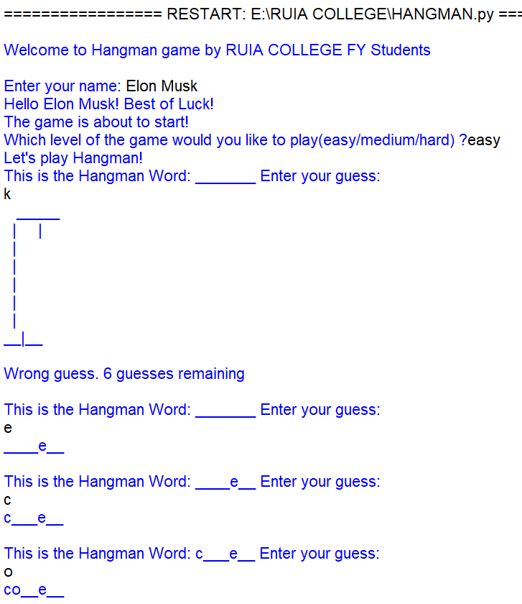**OUTPUT:**

